This document is to record the procedure that XY tried to reproduce the Fig3A in Ben’s paper

Goal: Reproduce the figure and understand how to generate 2-parameter Hopf bifurcation plot using Xpp-aut

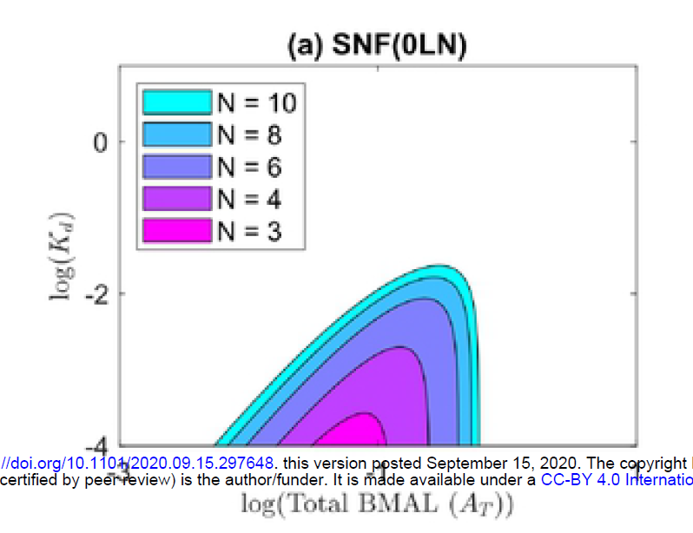

Mathematical Model:

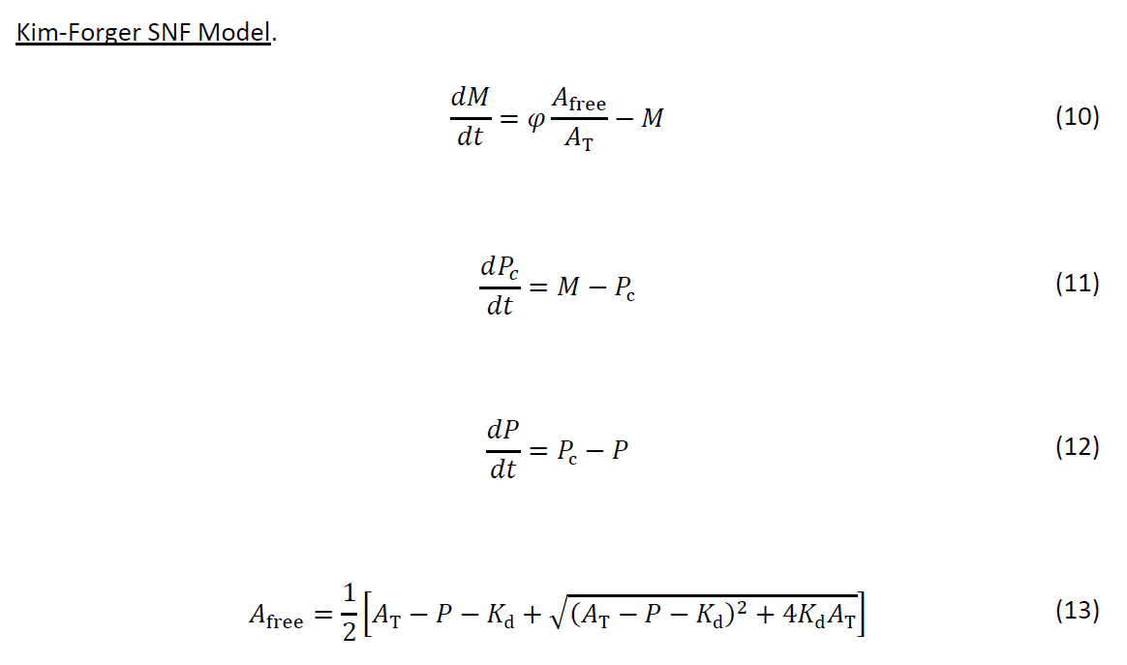

Step1: Modified Ben’s source code for SNF(0LN)

# Kim-Forger SNF Model

dM/dt=FCRTR*f(Pn,At,Kd)-M

dPc/dt=M-Pc

dPn/dt=Pc-Pn

f(P,A,Kd)=0.5*(1-P/A-Kd/A+sqrt(((1-P/A-Kd/A)^2)+4*Kd/A))

At=At0*FCATR

param Kd=1e-5, At0=0.001 # Modified to start with a stable steady state

# FCATR = "fold change in activator (BMAL) transcription"

# FCRTR = "fold change in repressor (PER) transcription"

param FCATR=1, FCRTR=1

done

Step2: Open Kim-Forger SNF_XY.ode using Xpp

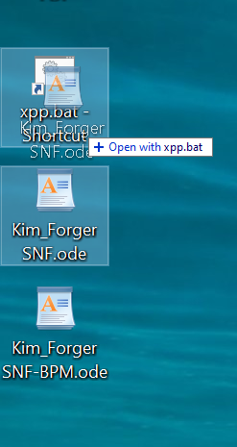

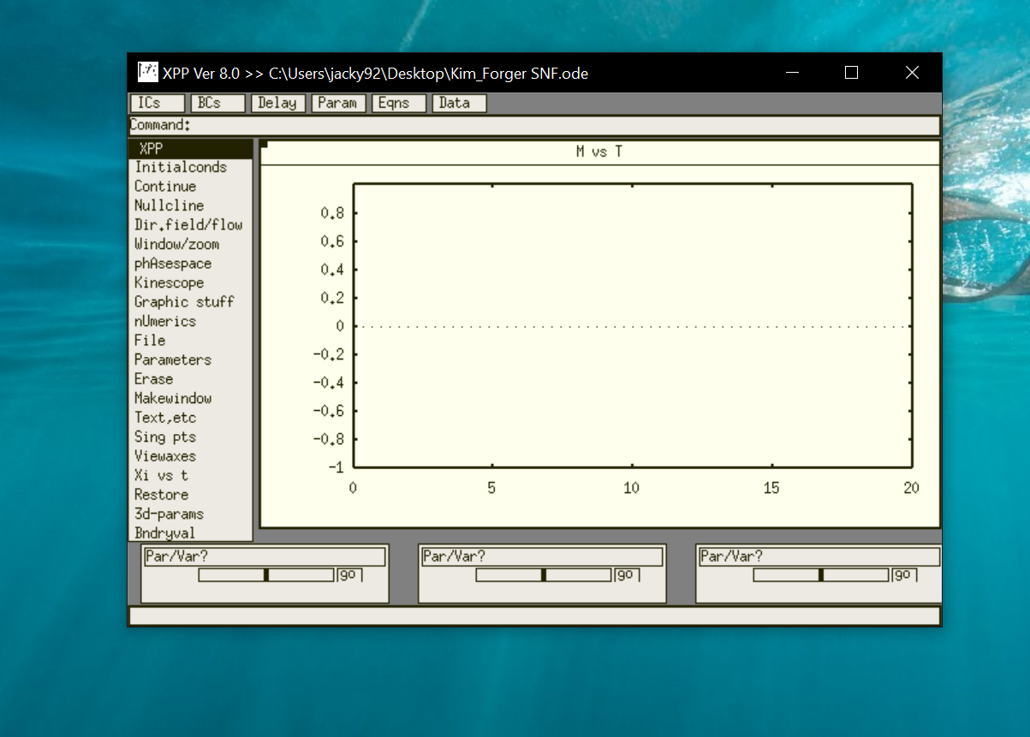

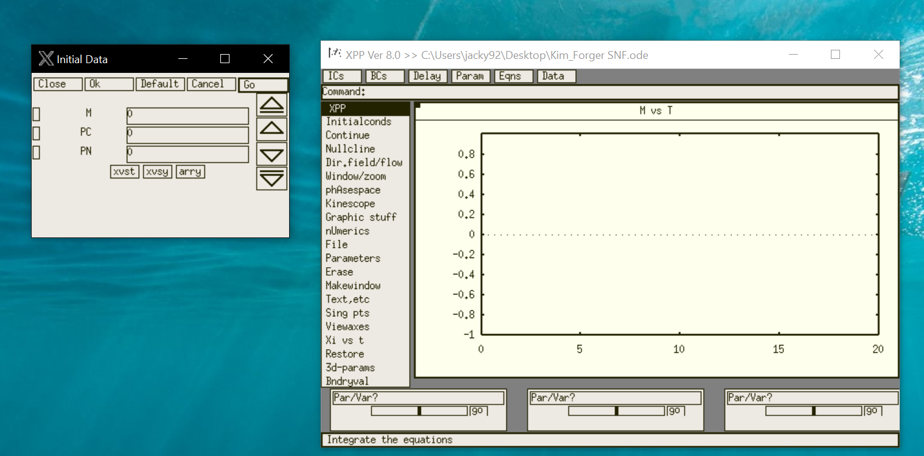

Click ‘Go’ to integrate with the initial condition.

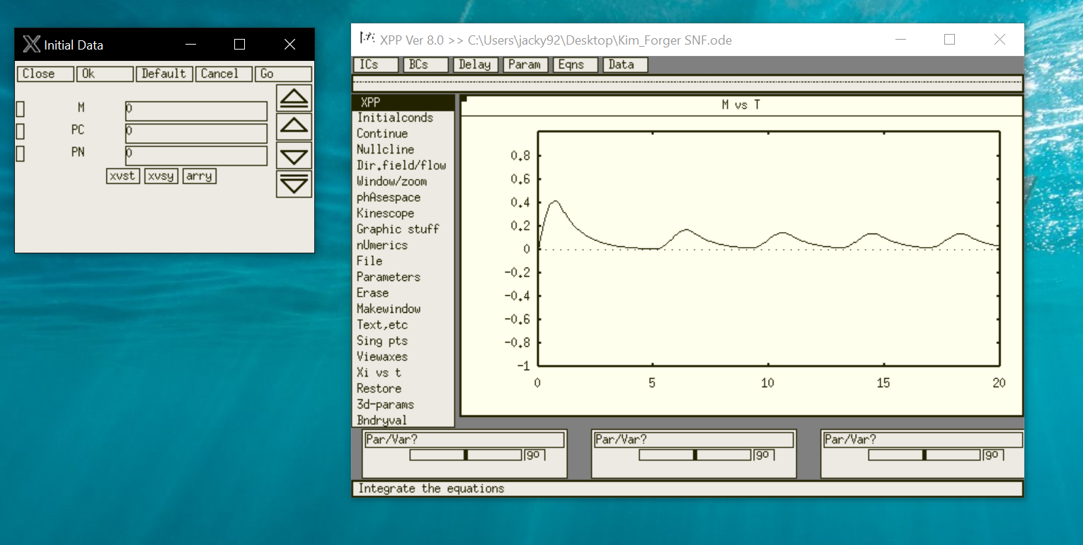

“Before you can use AUTO, you must prepare your system for it. You must start your bifurcation analysis from either a fixed point of your model, a periodic orbit, or a boundary value. AUTO seems to work best when you start from a steady state, but I have had success starting at periodic orbits.” ---- from

http://www.math.pitt.edu/~bard/xpp/help/xppauto.html

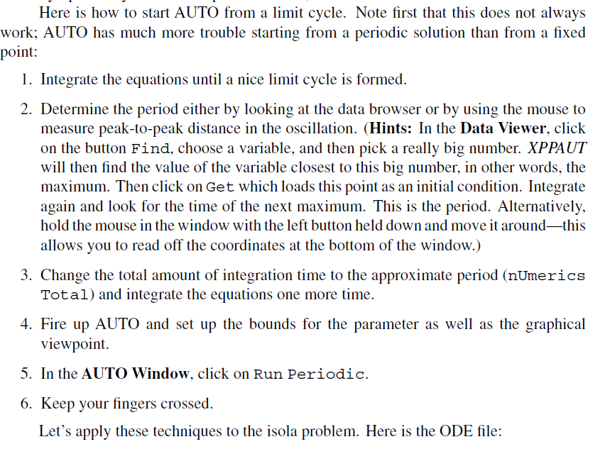

Step3: If you want to start at a periodic orbit, find one by integration and make sure you have converged to it. Then set the [total integration](http://www.math.pitt.edu/~bard/xpp/help/xppnumerics.html#total)time is the ``period'' of your orbit. This is what the AUTO interface uses as an approximate starting period.

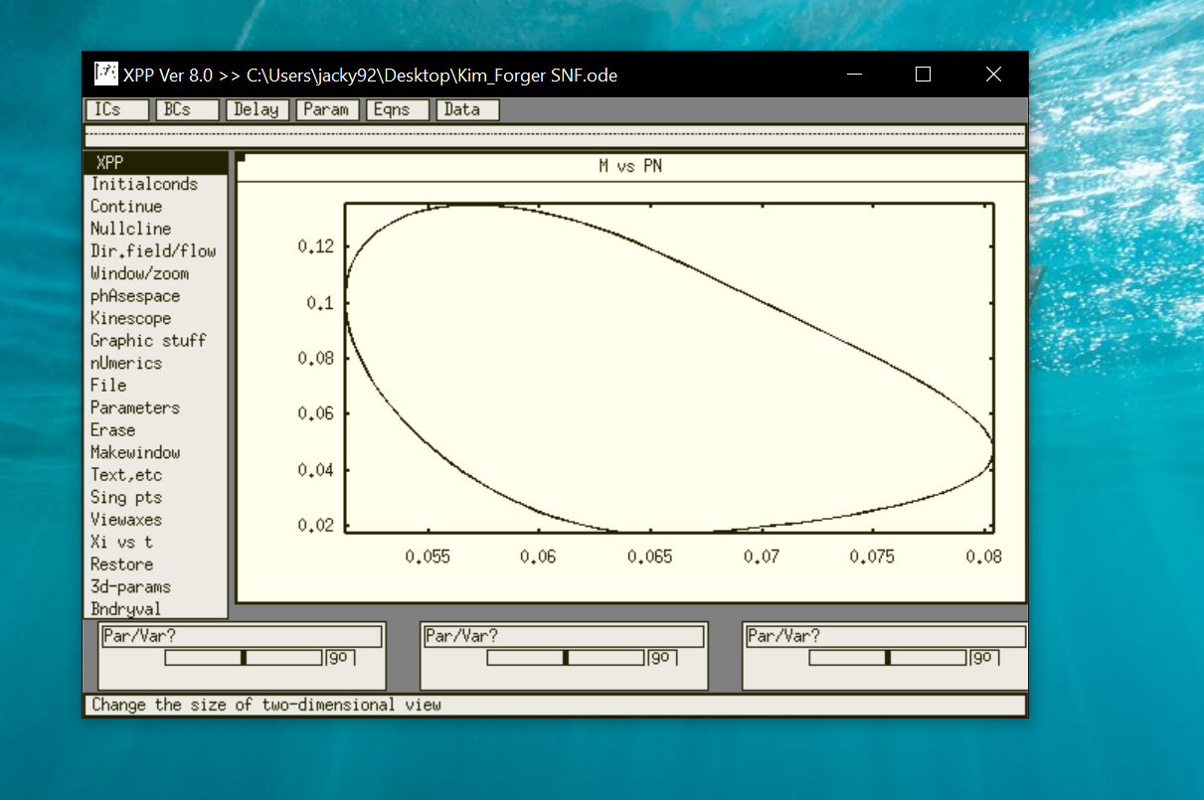

Click “Data”, “Find” maximum value and “Get” it as initial condition

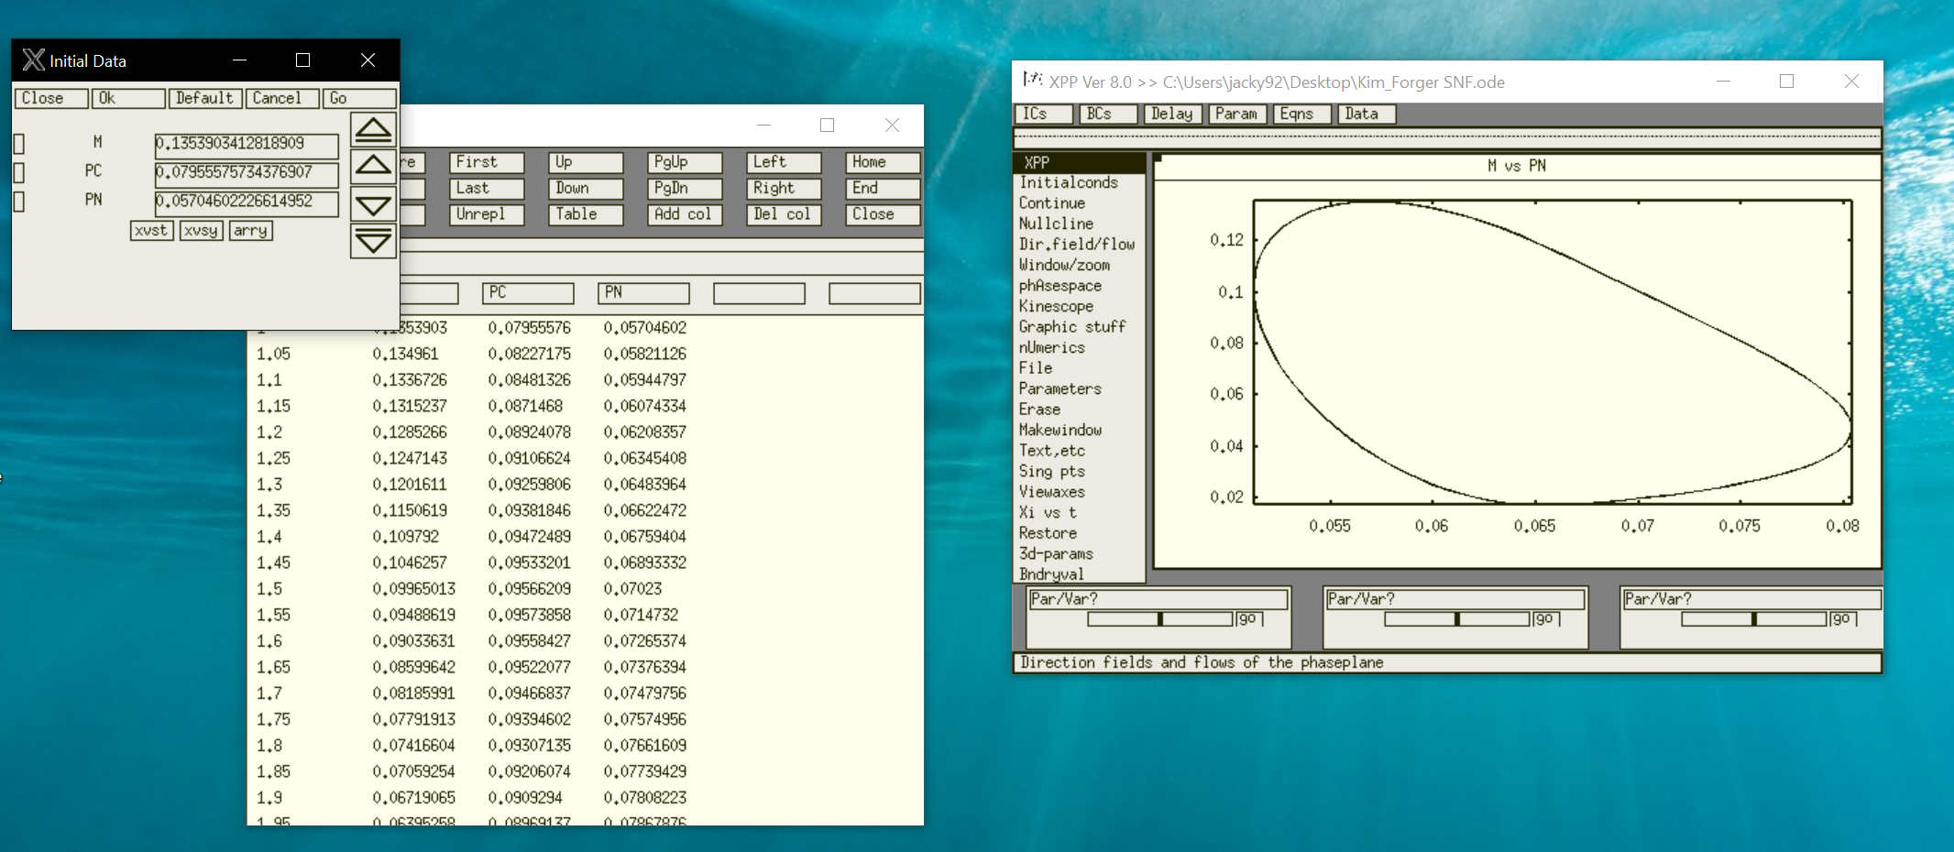

“Initial Condition” -> “Go” (run again using the updated initial condition) -> find the next maximum value and its corresponding time

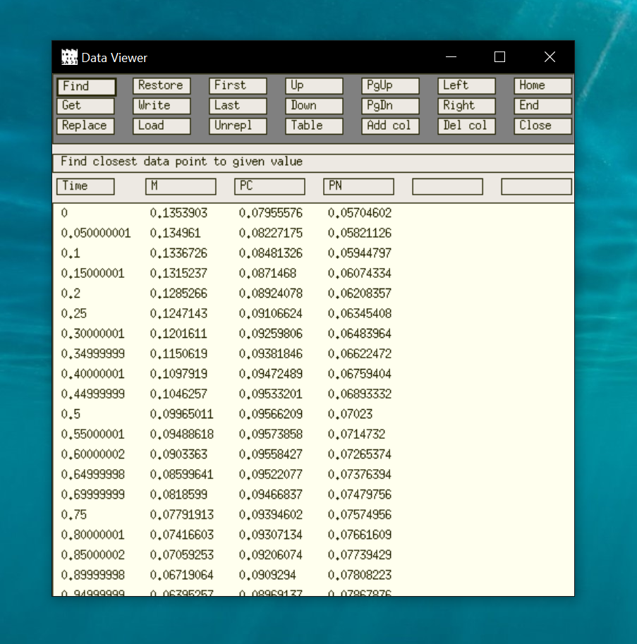

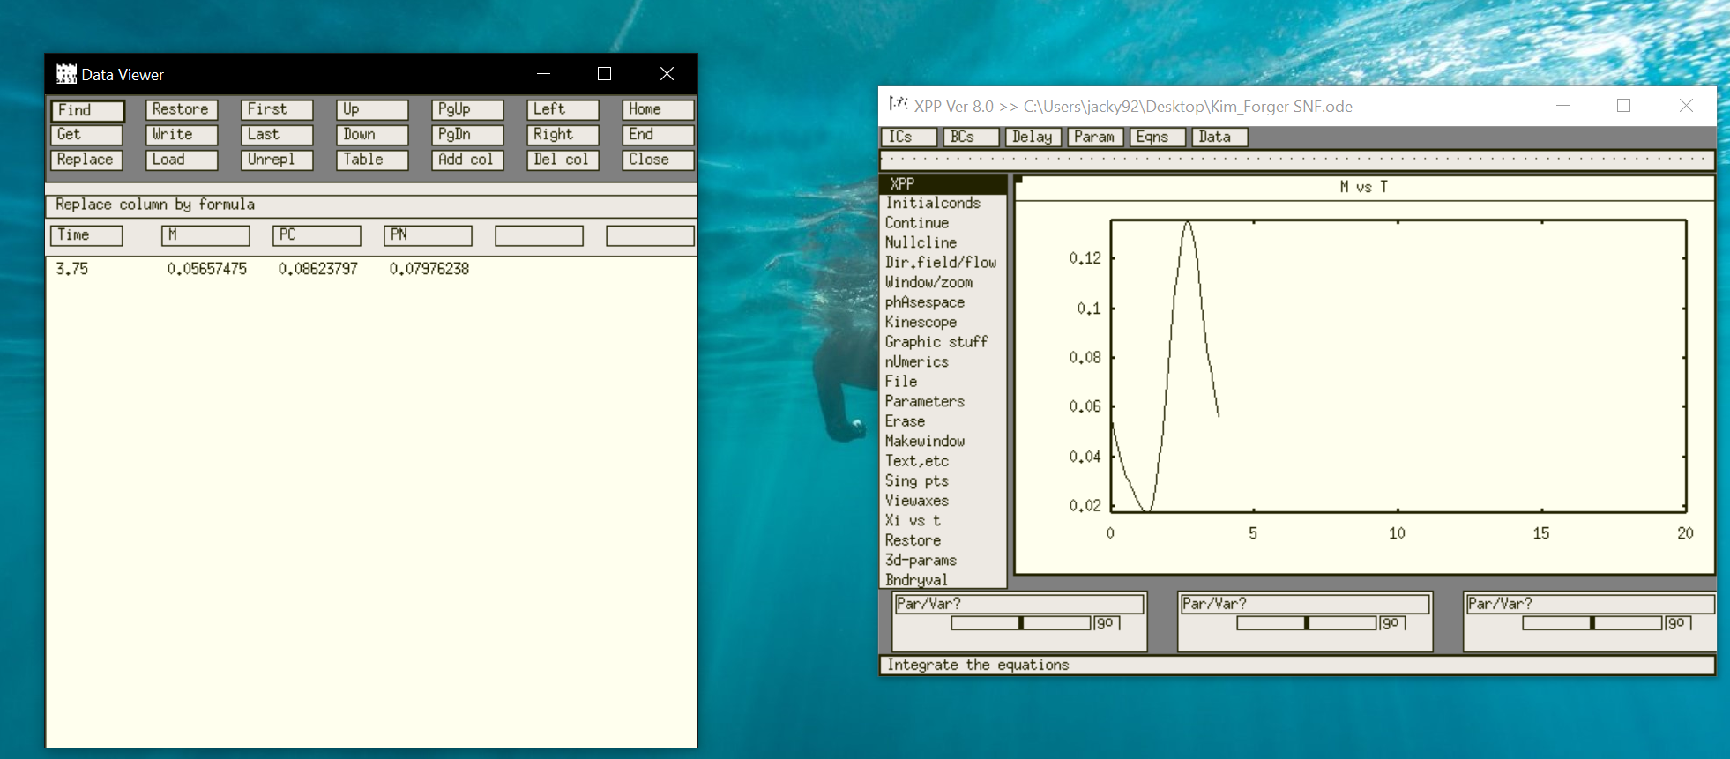

After following the procedure above, the period is 3.75

Change the integration time to the period by clicking “Numeri’s”-> “Total”

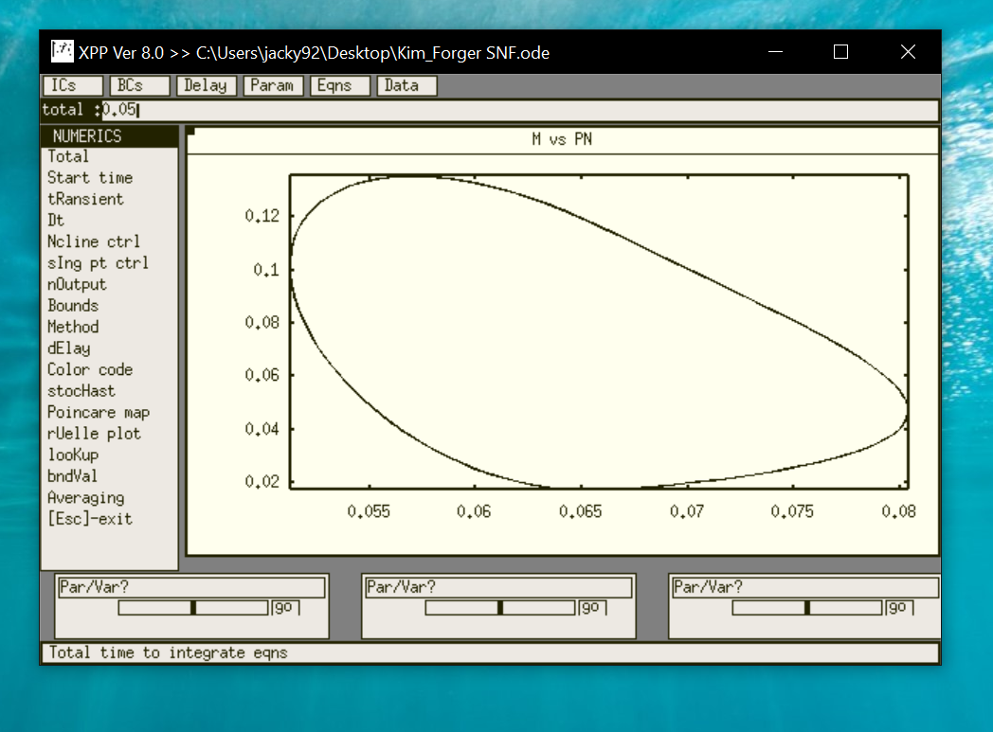

“Initial Condition” -> “Go” to run again.

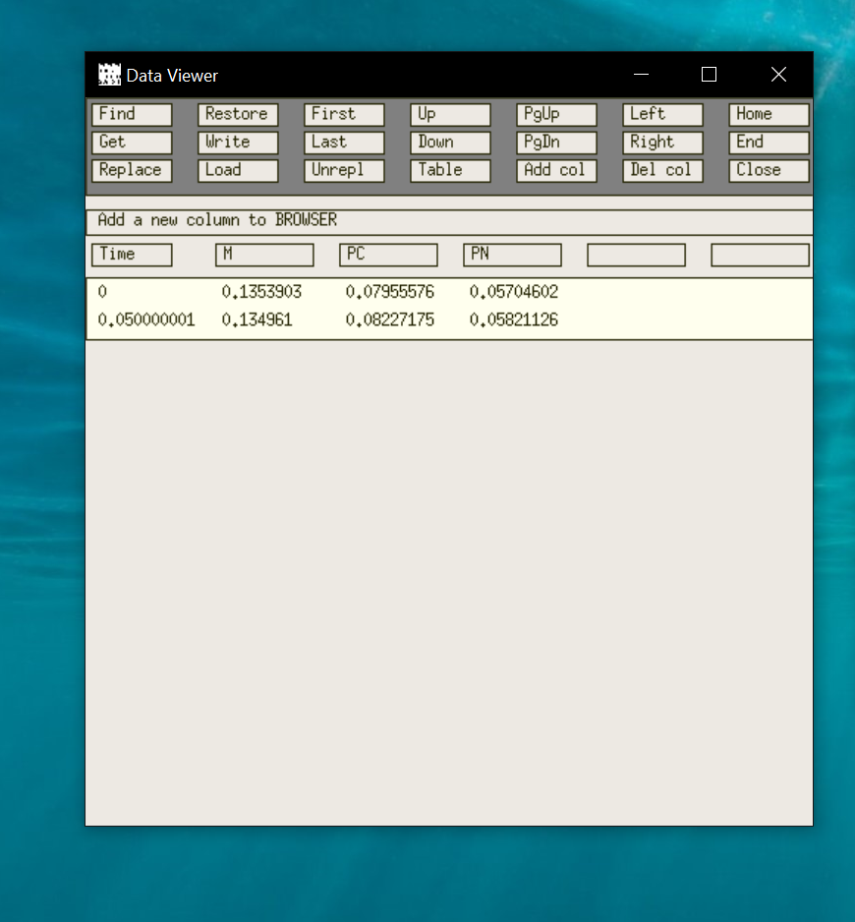

(This version of Step 3 start with limit cycle, which is not very easy to start with)

Based on Wei He’s advice, I start with a stable steady state to approach Hopf bifurcation

Step 3’: Therefore, use XY’s modification version, which has parameter At0 = 0.001 which has a fixed point steady state for M

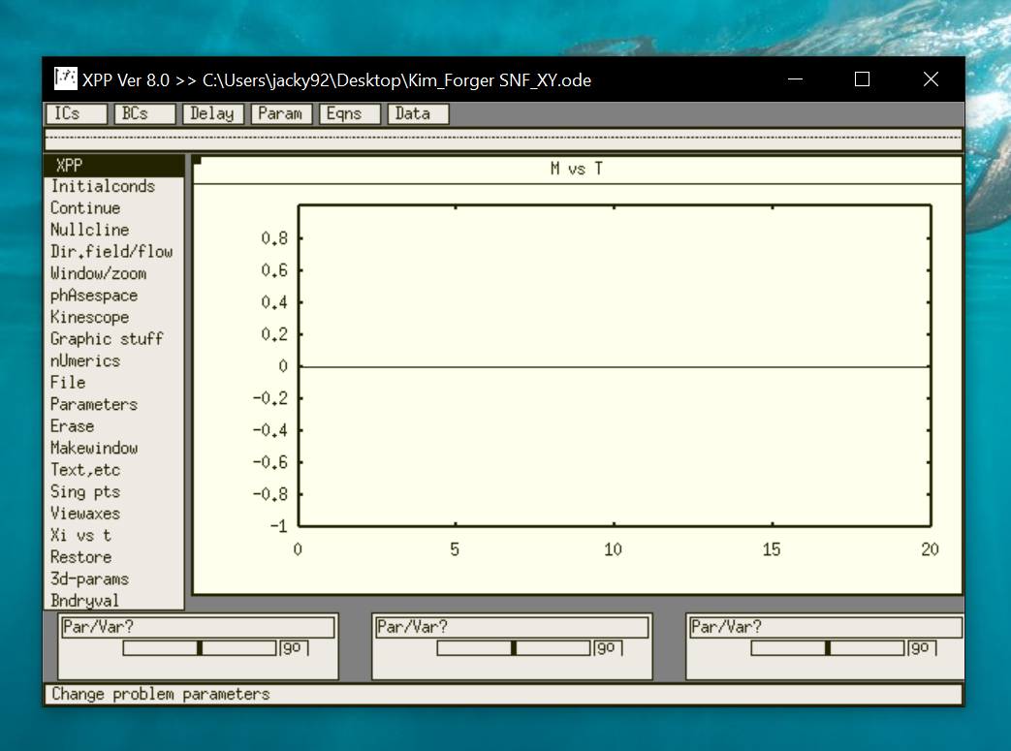

Step 4: Use “Auto”

Axes -> “Hi-lo”:

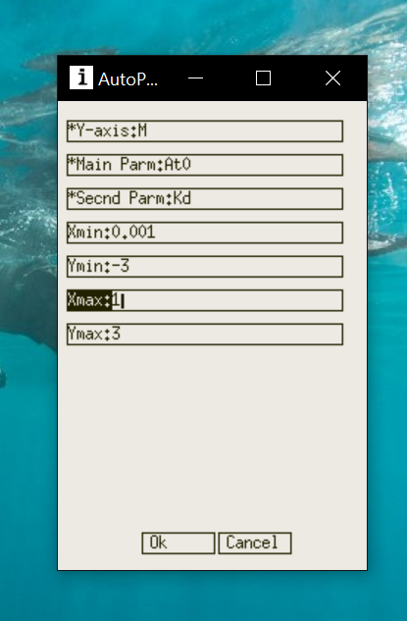

Numeric:

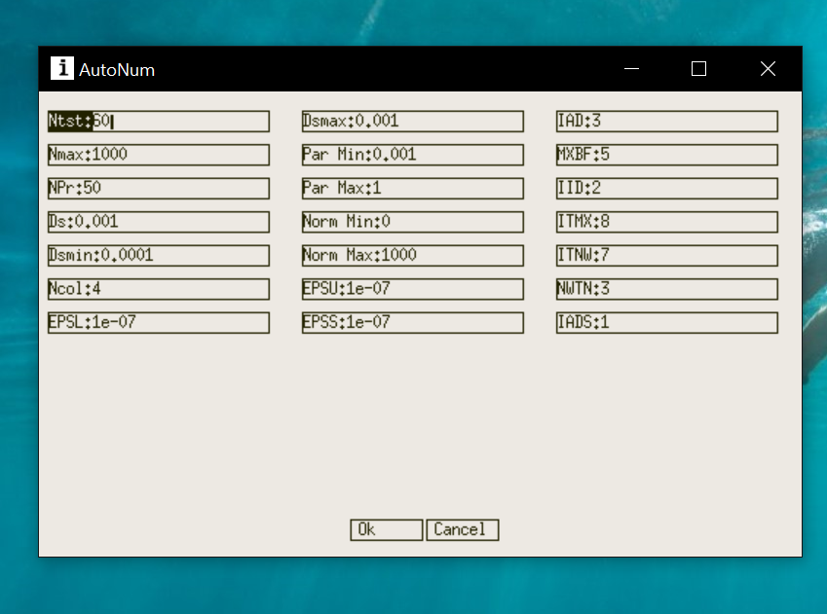

Step 5: “Run” -> “Steady State”

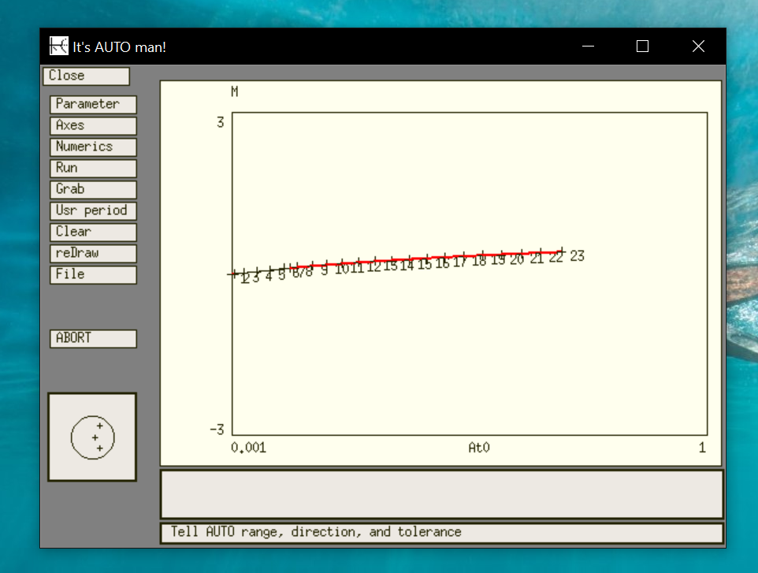

Step 6: “Grab” Hopf bifurcation point

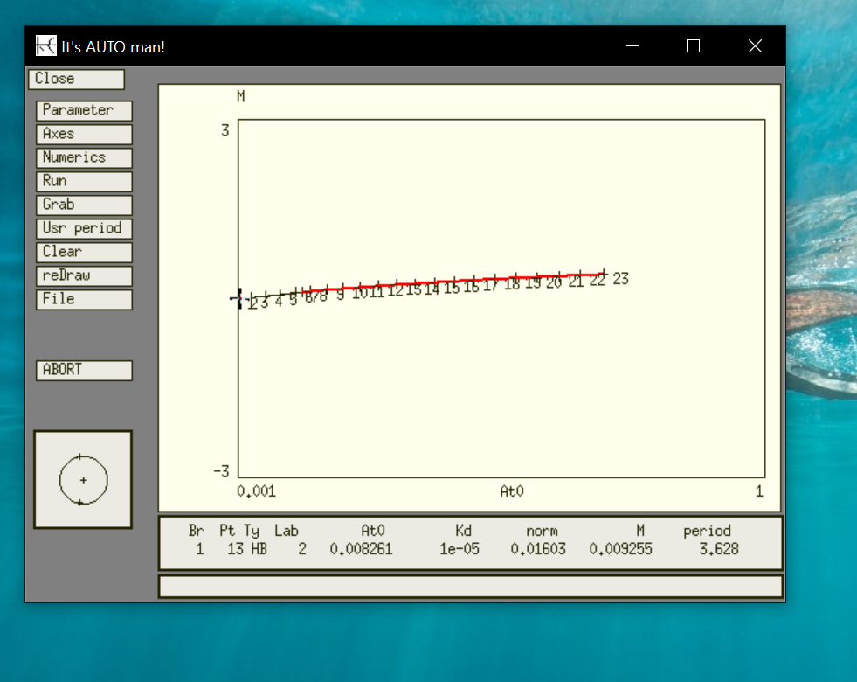

Step 7: “Axes” -> “two pair”

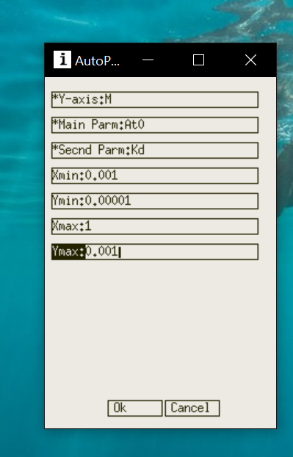

Step 8 “Run” -> “Two par”

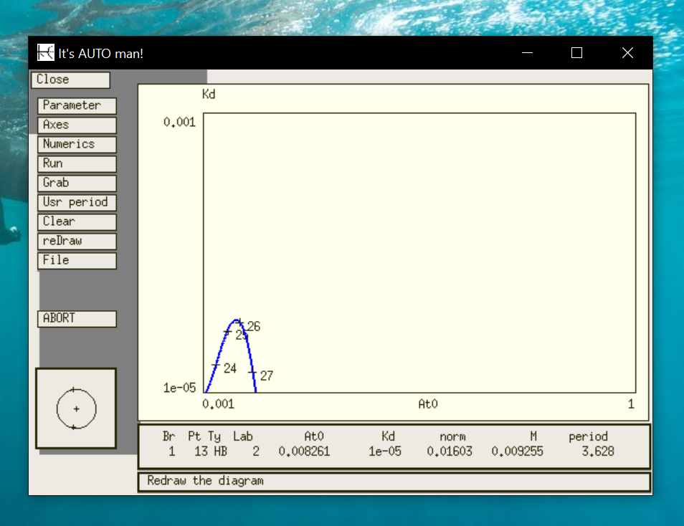

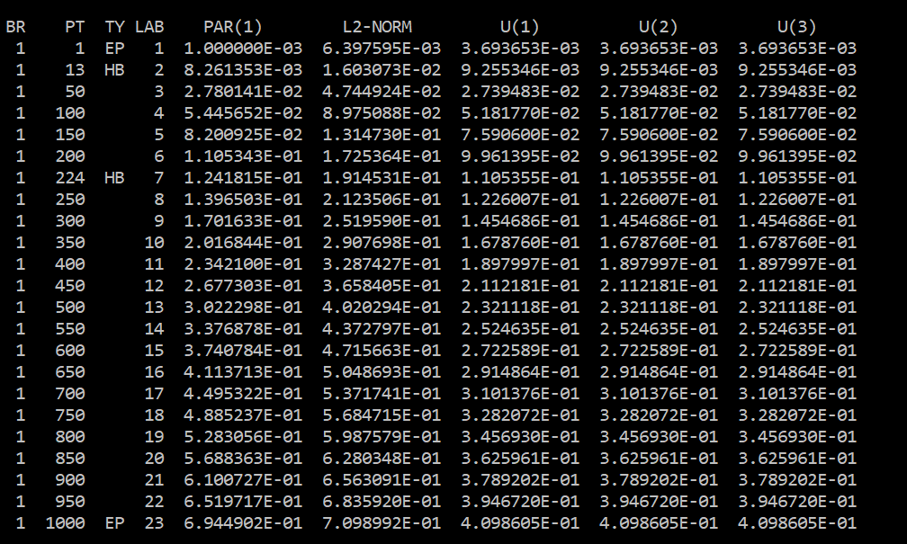

Summary for plotting 2-parameter bifurcation plot

Step1 Use Xpp to integrate the system to a fixed point (stable steady state)

Step2 Open Auto to generate 1-D bifurcation

Step3 Grab Hopf bifurcation point and modify axes for two parameter plot

Step4 Run-> Two par